- Internship Name : Data Analysis
- Task Name: Task 12: Data Visualization using Matplotlib
- Your Name : Shubhangi Naresh Khonde
- Internship Organization :
- Date:

1. Title
Creating Line, Bar, and Scatter Plots using Matplotlib on a Sample Dataset

2. Aim
To create line, bar, and scatter plots using the Matplotlib library in Python, and to format them with appropriate titles, axis labels, and legends.

3. Objectives
- To understand the basics of data visualization using Matplotlib.
- To plot a line chart, a grouped bar chart, and a scatter plot.
- To apply formatting such as titles, labels, legends, grid lines, colors, and markers.
- To interpret the information shown by each type of plot.

4. Introduction
Data visualization is the graphical representation of data. It helps in identifying trends, comparing values, and understanding relationships between variables. Matplotlib is a widely used Python library for creating static, animated, and interactive visualizations. Its pyplot module provides simple functions to build and customize different types of charts.
- Line plot: shows how a value changes over time or an ordered sequence.
- Bar plot: compares values across different categories.
- Scatter plot: shows the relationship between two numerical variables.

5. Tools and Technologies Used
- Programming language: Python 3
- Libraries: Matplotlib, NumPy, Pandas
- Environment: Jupyter Notebook / any Python IDE

6. Dataset Description
Two sample datasets were created for this task.
Dataset 1: Monthly sales of two products (units)
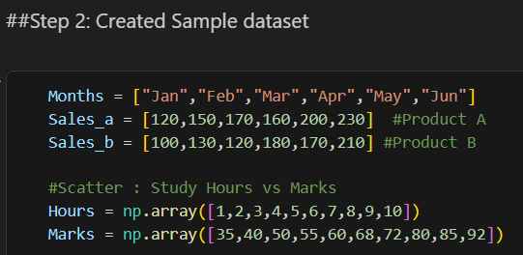
Month | Product A | Product B
Jan | 120 | 100
Feb | 150 | 130
Mar | 170 | 120
Apr | 160 | 180
May | 200 | 170
Jun | 230 | 210

Dataset 2: Study hours vs marks obtained
Study Hours | 1 | 2 | 3 | 4 | 5 | 6 | 7 | 8 | 9 | 10
Marks | 35 | 40 | 50 | 55 | 60 | 68 | 72 | 80 | 85 | 92

7. Methodology / Procedure
- Import the required libraries: matplotlib.pyplot, numpy, and pandas.
- Create the sample datasets as lists and NumPy arrays.
- Create a line plot using plt.plot() with markers and different line styles for each product.
- Create a grouped bar plot using plt.bar() by shifting the bar positions for the two products.
- Create a scatter plot using plt.scatter() and add a trend line using np.polyfit().
- Format each plot using plt.title(), plt.xlabel(), plt.ylabel(), plt.legend(), and plt.grid().
- Display the plots using plt.show() and save the figure using plt.savefig().

8. Formatting Techniques Used
Feature | Function Used | Purpose
Title | plt.title() | Describes what the chart represents
Axis labels | plt.xlabel(), plt.ylabel() | Identify the variables on each axis
Legend | plt.legend() | Distinguishes multiple data series
Grid | plt.grid() | Improves readability of values
Markers and colors | marker=, color= | Highlight data points and separate series
Figure size | plt.figure(figsize=()) | Controls the size of the output

- Output:
- Figure 1: Line plot showing the monthly sales trend of Product A and Product B.
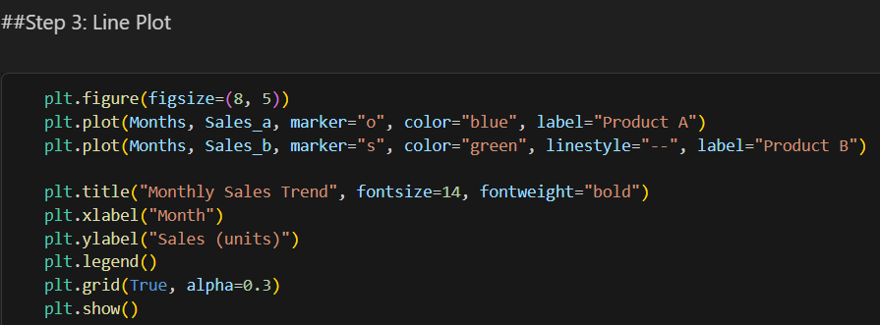
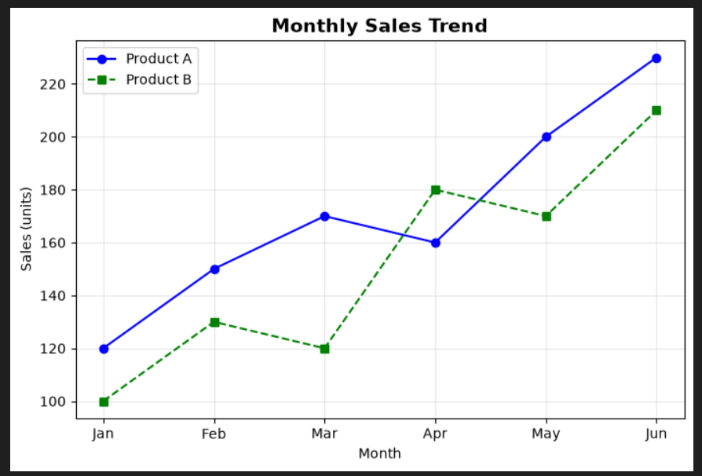
- Figure 2: Grouped bar plot comparing monthly sales of both products.
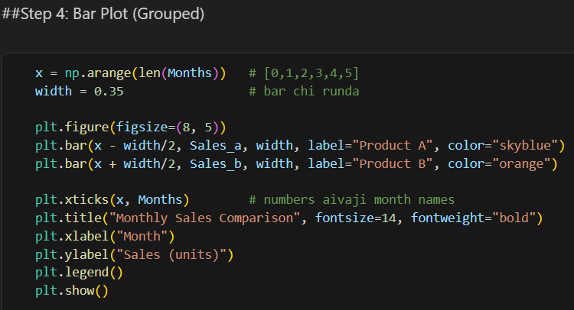

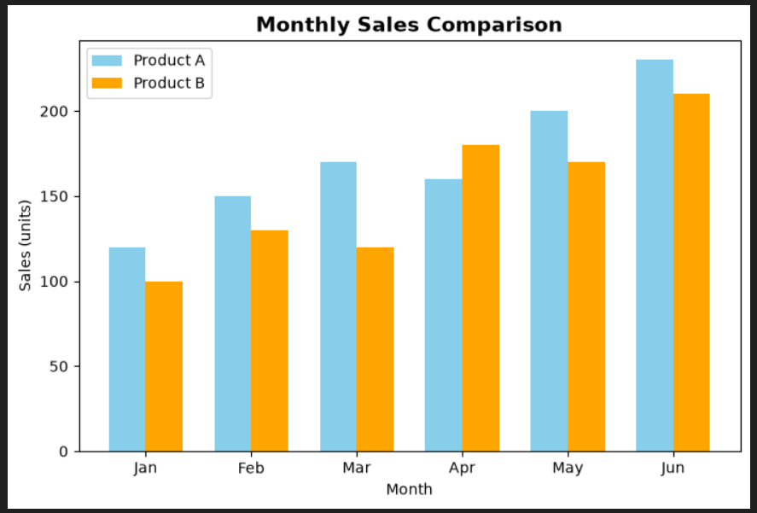

- Figure 3: Scatter plot of study hours versus marks, with a trend line.
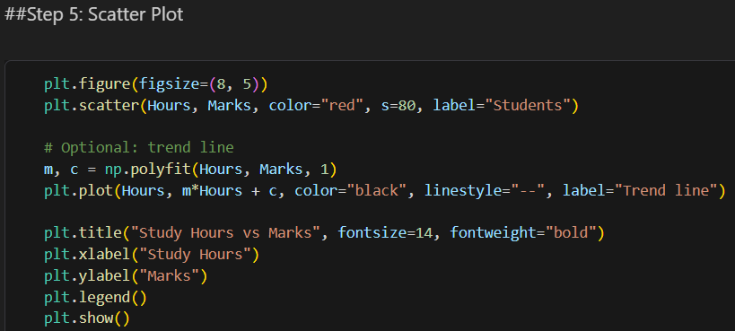
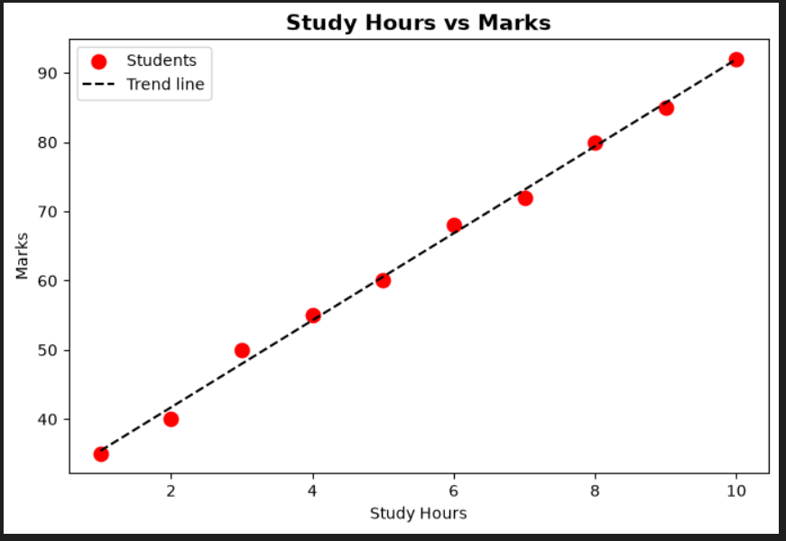
9. Observations
- Line plot: Sales of both products increased from January to June. Product A showed steady growth, while Product B fluctuated, with a dip in March and a sharp rise in April.
- Bar plot: Product A had higher sales than Product B in most months. Product B exceeded Product A only in April.
- Scatter plot: The points rise from the lower left to the upper right, showing a strong positive correlation between study hours and marks. The trend line confirms that marks increase as study hours increase.

10. Conclusion
Line, bar, and scatter plots were successfully created using Matplotlib. Each plot type suits a different purpose: line plots for trends, bar plots for comparisons, and scatter plots for relationships between variables. Adding titles, axis labels, and legends makes the charts clear and easy to interpret. Matplotlib proved to be a simple and flexible tool for data visualization in Python.

